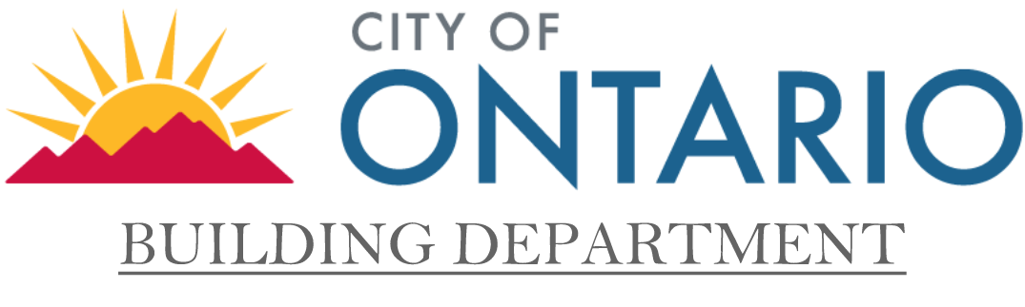
Application for Unreasonable Hardship
Exception to Disabled Access Requirements

Plan Check No.: _________
Date:_________________
Please print legibly or type
Project Name and Address:

Owner: | Telephone (include area code):
Applicant Name (please print):  Signature of applicant:______________________Date:_____________ | Telephone (include area code):

- Section 11B-202.4 (exception 8) Exception Applicable to existing buildings where the construction cost at this tenant space over the last three years does not exceed the valuation threshold amount. The specific accessibility feature that creates a hardship may be exempted but not all the accessibility features. The area of the alteration itself may not be exempted. |  |  | Valuation Threshold Amount of  $  Amount will change in January
Access Features  Item: Provide description below: | Does this feature  meet the latest  edition of Title 24? | If not, is this feature going to be made accessible as part of this permit? | Cost of making feature accessible  (attach documentation)
1. Accessible Entrance | YES_____ NO_____ | YES_____ NO_____ | $
2. Accessible route to the altered  Area. | YES_____ NO_____ | YES_____ NO_____ | $
3. At least one accessible restroom for each sex or one accessible unisex (single-user or family) restroom. | YES_____ NO_____ | YES_____ NO_____ | $
4. Accessible telephones  ( If provided). | YES_____ NO_____ | YES_____ NO_____ | $
5. Accessible Drinking Fountains  (if provided). | YES_____ NO_____ | YES_____ NO_____ | $
6. When posible, additional  Accessible elements such as  parking, signs, storage and alarms. | YES_____ NO_____ | YES_____ NO_____ | $
7. Other: Specify below
 | YES_____ NO_____ | YES_____ NO_____ | $
Total cost of access features provided (A):  Total cost of construction of project and other work performed over the last 3  years in this tenant space (B):  Percentage of total cost of project (A+B): |  |  | $
 |  |  | $
 |  |  | %
Description of features provided:
It is requested that the above-named project be granted an exception from the requirements of the State of California Title 24 accessibility, as specifically noted below:
Application for Unreasonable Hardship
Exception to Disabled Access Requirements
(Continued)

Hardship Documentation No.: _________
Plan Check No.: ___________________
Date:___________________________

* Include cost of other work performed over the last 3 years in total valuation B on sheet one unless 20% of valuation of
individual remodel has already been expended on access feature (provide documentation below, including any previously
approved Unreasonable Hardship Forms).

Alterations performed over the last three years in this tenant space:
Permit Number | Date | Valuation | Was 20% of cost of project spent on access feature?

Request Granted
Unreasonable Hardship Exception request is approved based on Section 11B-202.4 of Title 24. Access features
listed in part A of the form shall be provided as part of this permit.
Specific Exception(s) requested is approved based on Section(s) ____________________. All other access features shall
be provided as specified in Title 24.
Request denied. If you disagree with this determination, you may seek an appeal through the Chief Building Official.
Name of Chief Building Official:  Name and Title (please print)  Signature Date | Recommended by:  Name and Title (please print)  Signature Date
For Jurisdiction Use Only

